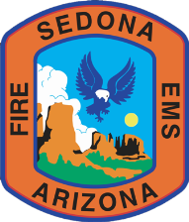
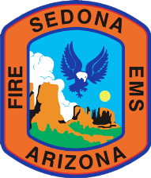

Fire Chief Report
Sedona Fire District
September 2017
Presented to the Fire Board on October 18, 2017

Call Summary and Response Times (Year-to-Date 2017):

Incident  Types by NFIRS | Jan | Feb | Mar | April | May | June | July | Aug | Sep | Oct | Nov | Dec | 2017 YTD  Totals | 2016 YTD  Totals
Rescue & EMS* | 238 | 211 | 257 | 246 | 272 | 284 | 253 | 251 | 251 |  |  |  | 2,263 | 2,378
*Includes Interfacility Transports (Emergency & Non-Emergency) | 49 | 59 | 49 | 52 | 64 | 45 | 46 | 49 | 59 |  |  |  | 472 | 583
Fire | 4 | 5 | 4 | 6 | 4 | 5 | 5 | 4 | 2 |  |  |  | 39 | 46
Overpressure Rupture/ExplosionOverheat (No Fire) | 0 | 2 | 0 | 2 | 0 | 0 | 1 | 0 | 0 |  |  |  | 5 | 2
Hazardous Condition (No Fire) | 4 | 2 | 7 | 5 | 3 | 3 | 5 | 6 | 3 |  |  |  | 38 | 37
Service Call | 59 | 65 | 53 | 50 | 75 | 94 | 86 | 60 | 53 |  |  |  | 595 | 527
Good Intent Call | 14 | 12 | 14 | 13 | 18 | 18 | 20 | 14 | 20 |  |  |  | 143 | 132
Special Incident | 0 | 0 | 1 | 1 | 1 | 1 | 3 | 2 | 1 |  |  |  | 10 | 5
False Alarm/False Call | 13 | 11 | 11 | 19 | 9 | 16 | 24 | 16 | 10 |  |  |  | 129 | 106
Severe Weather & Natural Disaster | 0 | 0 | 0 | 0 | 0 | 0 | 2 | 0 | 0 |  |  |  | 2 | 2
Sub-Total | 332 | 308 | 347 | 342 | 382 | 421 | 399 | 353 | 340 |  |  |  | 3,224 | 3,235
Mutual/Auto Aid | 5 | 7 | 9 | 6 | 11 | 21 | 9 | 18 | 6 |  |  |  | 92 | 81
TOTAL | 337 | 315 | 356 | 348 | 393 | 442 | 408 | 371 | 346 |  |  |  | 3,316 | 3,316
Average Emergency Response Time &  # of Incidents | 7:11  91 | 6:00  76 | 6:12  129 | 6:08  128 | 5:39  113 | 7:08  130 | 6:08  131 | 6:03  152 | 7:13  107 |  |  |  | 6:25  1,190 | 6:32  1,182

Backcountry Rescue Incidents:
YTD 2017 = 83 / TOTAL IN 2016 = 73

In September 2017, SFD responded to 9 backcountry rescues including hike-outs and technical rescues compared to 11 such incidents for the same time period in 2016.

Grants Update (SEPTEMBER 2017):
Agency | Description  of Request | Amount * | SFD  Portion | Status
ADEQ Grant Funds Request | HAZ-MAT Tools | $4,810 | No Match | Received on 9-20-17
AFG-FEMA | Type 3 Brush Attack Vehicle | $305,715 | 5% match | Denied on 10-6-18
AFG-FEMA | Replacement for 12 mobile radios | $27,555 | 5% match | Denied on 10-6-18
AFG-FEMA | Regional leadership courses to be hosted at SFD | $122,855 | 5% match | Denied on 10/6/18
NAEMS | EMS Documentation Class | $12,000  Cost of Class | $6,000  (50% match) | Fulfilled
Wal-Mart | Infant/Child Car Seats | $800 | No Match | Fulfilled
* The amounts listed above are estimated based on projected amounts requested; however, the actual amounts may vary based on the final projects and any restrictions or necessary changes to awarded grants.

Incident Counts by Station
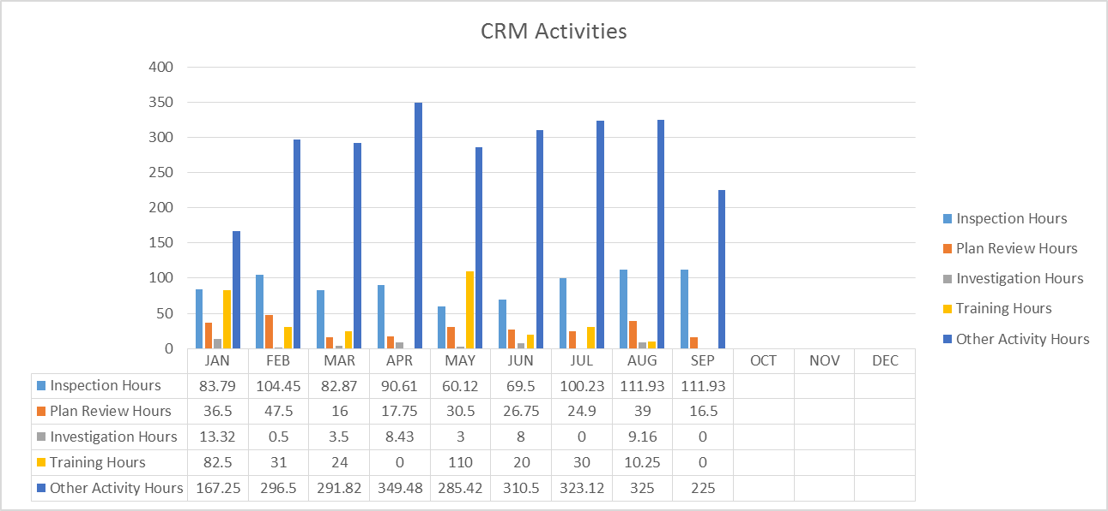
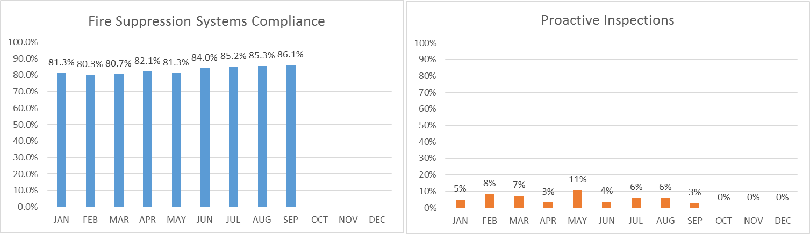

Community Risk Management
Notable Activities:
- CRM received plans for the Elements by Westin in the Village of Oak Creek (VOC).
- Finishing up with the outlet mall in the VOC – Tuesday Morning will be moving into the newly remodeled building. The Majestic Theater & Speakeasy has also been issued a Certificate of Occupancy by Yavapai County and is in operation as well.
- CRM staff is expecting plans for the storage units in the VOC any day.
- Underground work for the new Thai Spices Restaurant is underway.
- CRM staff has been emphasizing the importance of proper addressing when we are conducting inspections and this is really starting to pay off. We are getting more businesses to post large, easy-to-read addresses on their buildings.
Note: The graphs below indicate the percentage of fire protection systems we inspect that are compliant; percentage of our proactive Fire and Life Safety inspections; number of Inspections, Plan Reviews, Consultations, and Training Hours for CRM during the month of September 2017.

Training Information – SEPTEMBER 2017

The Training Office gathers information on post-secondary education, certificates of completion, and major conferences. SFD provides daily drills and other training; more significant events are included:

Required Training:
- Six SFD members attended Arizona State Fire School this year for firefighting classes ranging from skills training to fire leadership. This was a great opportunity for them to be instructed by subject matter experts and utilize the training center to perform those skills. We received a scholarship fund that lowered hotel rates to $35.00 a night.
Certifications:
- Engineer Tim Kriegel attended the 2017 Public Safety Peer Support Association Conference.
- Training Officer Michael Duran completed a Wildland IQS-Web Class. This class will support the Training Division and enhance the membership with the current wildland task book. Also, Training Officer Mike Duran is currently working on a Wildland Training Specialist Task Book.

Associates/Bachelor’s Degrees:
- Currently, several members are working toward their Associate and Bachelor degrees. Firefighter David Yingling completed his Associate in Applied Science Degree in Emergency Response and Operations.
Training / Education Statistics:
- Number of Trainings and Classes: 144
- Number of Attendees: 584
SEPTEMBER 2017 Donations to SFD
NPS In-Kind Payments: $12.25
TOTAL = $12.25
- Total Training Hours: 1,572
Attached to this report is a National Fire Incident Report System (NFIRS) Incident Code Guide explaining how calls are assigned into the 9 categories represented on the Call Summary & Response Times chart on Page 1.

